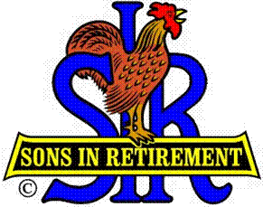
Las Trampas Branch 116
BEC Meeting Agenda
March 18, 2019, 9:30 AM
The Mission of SIR is to improve the lives of our members through fun activities and events – while making friends for life.

09:15 Coffee Available
09:30 Call to order; Secretary confirm a quorum
09:31 Secretary – Fred Schafer – Approval of February 18 minutes
09:33 Treasurer – Jim Nickels – Report including Dues payments
09:37 Standing Reports
- Attendance – Jim Flessner – Attendance, Missed Luncheon Receipts
- Membership – Phil Goff
- Spring Fling – Alan Fitzgerald
- Activities Chair – Fred Wachowicz
- Publicity Chair – Jim McCormick
- Member Relations Chair – Sam Beret
09:52 Big SIR Report – by Jerry Hicks
- Department Heads (RAMP) doing great
- Have not heard about Nominating Committee training
- Will ask MR to purge the “Inactive List”
09:59 Little SIR Report – Michael Barrington
1. Speaker
10:02 Old Business
- Audit Report of Golf Committee – Bill Ginter & Harry Oberle
10:07 New Business:
1. Golf Area Competition – Bernie Wroblewski
2. Electronic Payments – Jim Seven
10:18 Other Discussion
10:20 Adjourn; Next BEC Meeting, April 15, 0930

